Task 2 – Automation Workflow

Workflow Objective
Fetch cryptocurrency data from a public API, process it using Python, and filter records based on price.

Workflow Steps
- Manual Trigger
- HTTP Request (CoinGecko API)
- Python Code (extract fields)
- IF Condition (price > 1000)

Result
- True Branch: Bitcoin, Ethereum
- False Branch: Tether, BNB, XRP

Screenshots
- Workflow overview
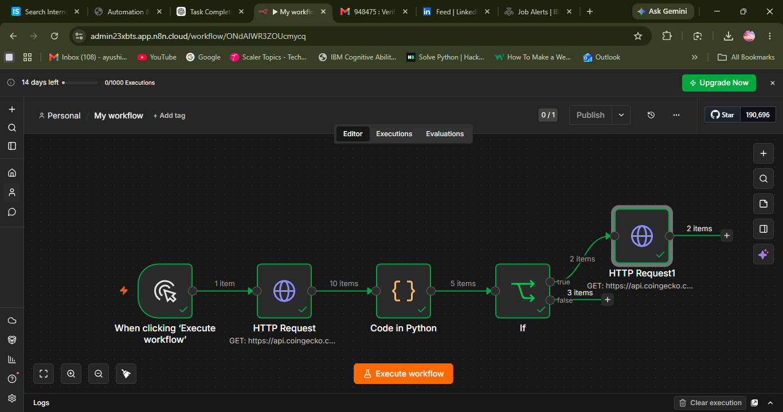

- HTTP Request output
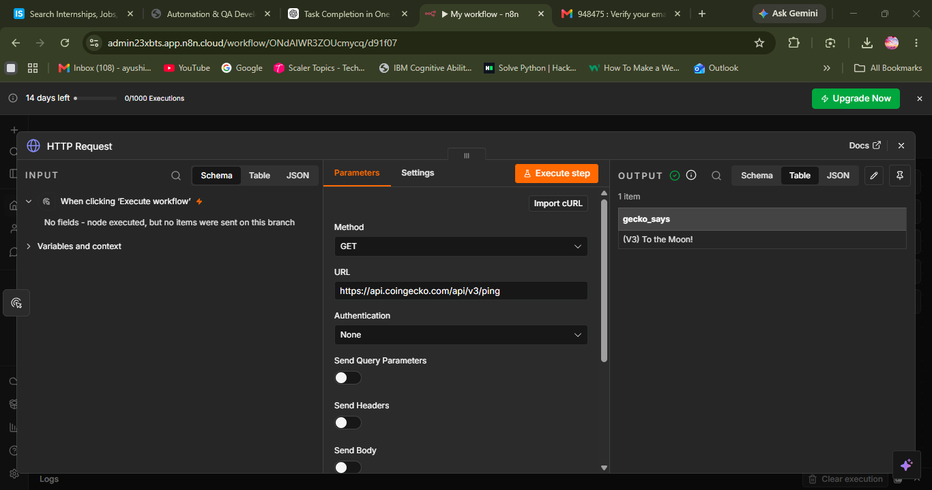
- Python output
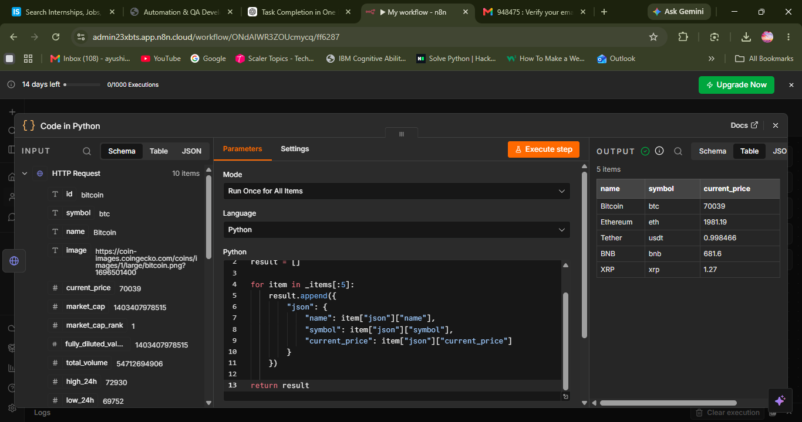

- IF output
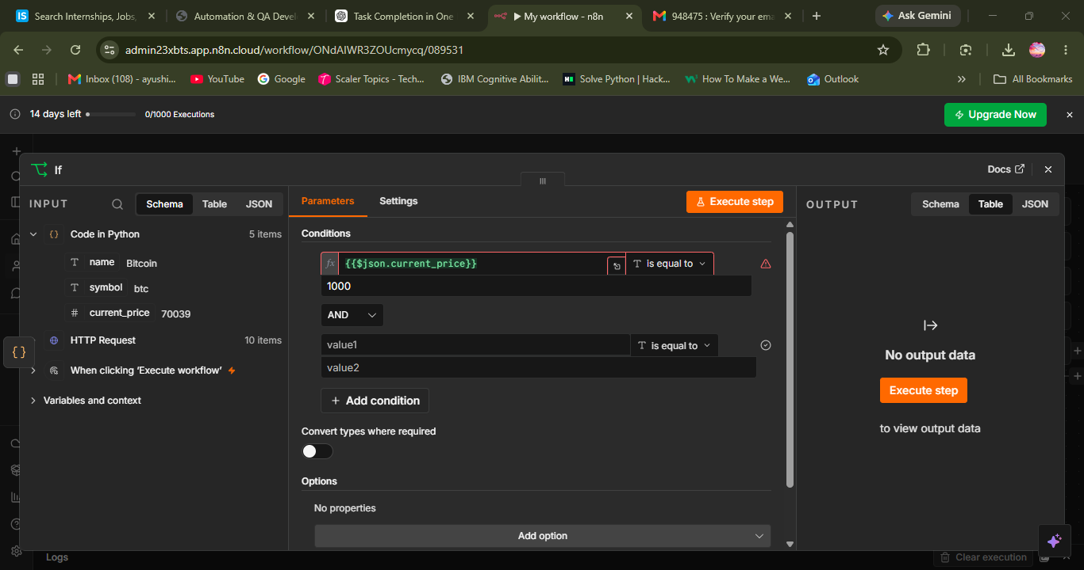
- Second HTTP Request output
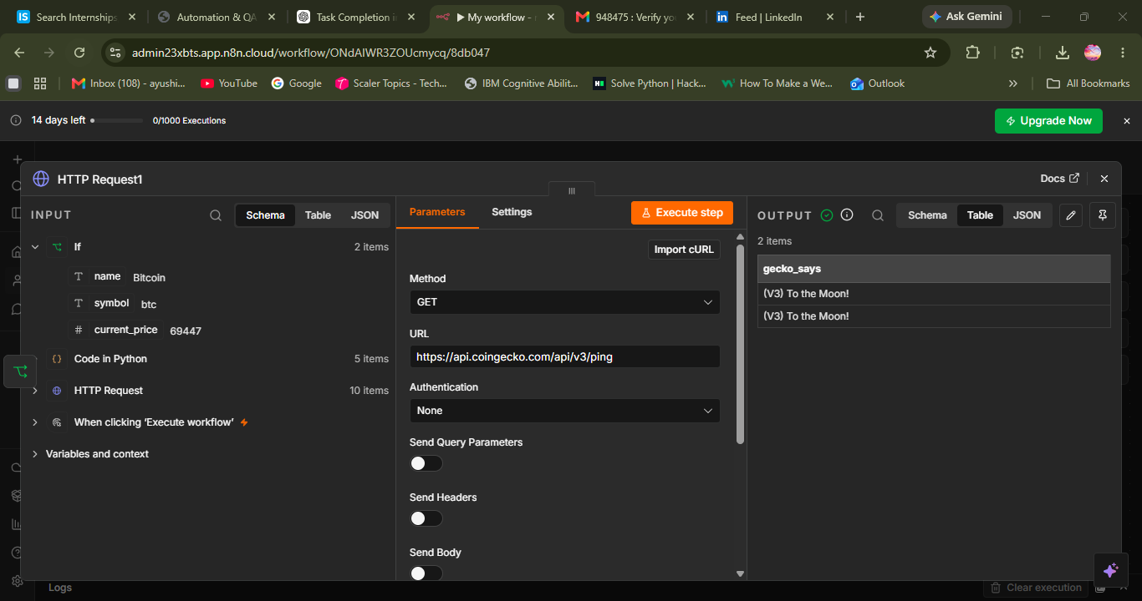
- Google Sheets Output

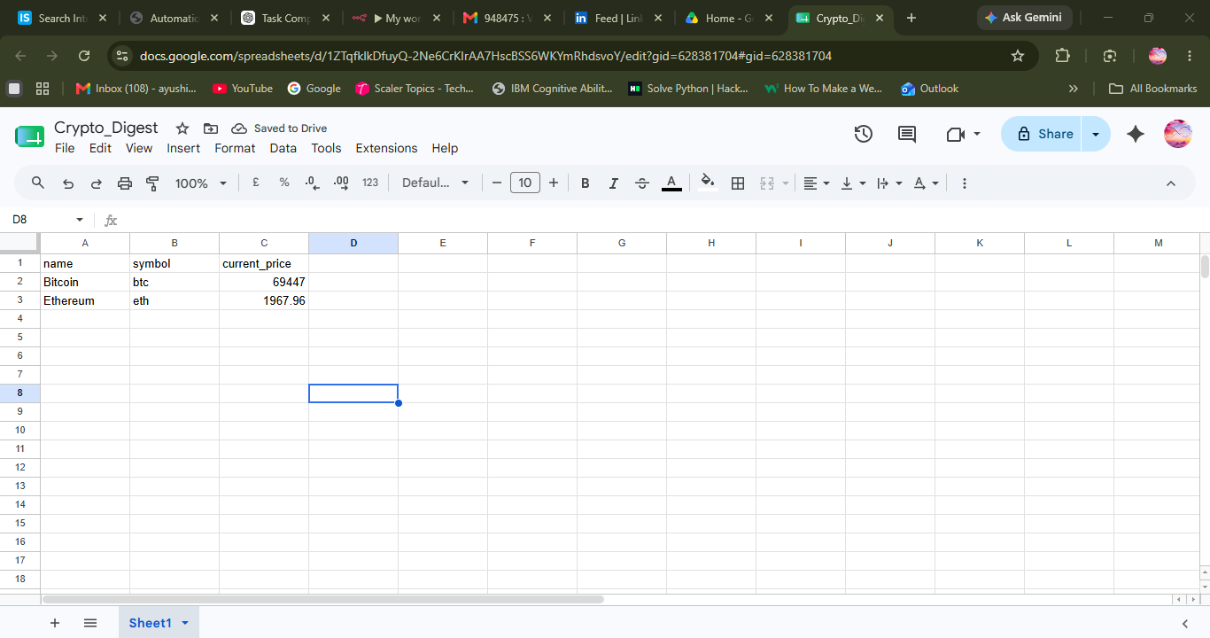

Conclusion
The workflow was successfully created and executed in n8n. Cryptocurrency market data was fetched from the CoinGecko API, processed using Python, filtered using conditional logic, and qualifying records were stored in Google Sheets. Coins with a current price greater than 1000 were routed through the True branch and triggered a second API request successfully. The workflow demonstrates API integration, data transformation, conditional routing, and Google Sheets automation.

